**KeyStore Information:**

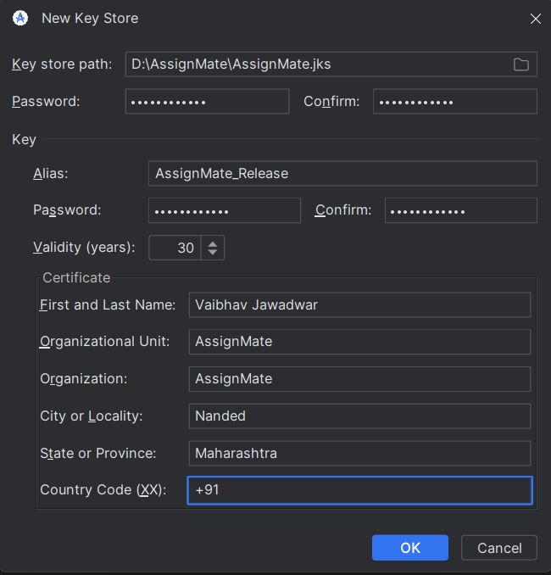

**Password for Both(Key Store and Alias):** Vaibhav@2006